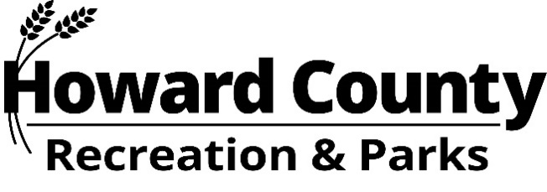

Summer Concert Series 2026
Are you looking for an advertising opportunity that puts you in touch with the community? Howard County Recreation & Parks is currently accepting cash sponsors for the 2026 Summer Concert Series. Businesses can help us preserve our 30 + year tradition of bringing free, quality musicians to the Howard County community. In addition to helping us support the arts, you will advertise your business directly to Howard County residents.

Your Name:
Business/Organization Name:
Business/Organization Address:
Phone Number: Email Address:

IN-KIND LEVEL (Before June 5, 2026*)
- Host a table at one concert
- Recognized as a sponsor on the Summer Concerts Webpage with your logo (www.howardcountymd.gov/summerconcerts)
- Recognized as a sponsor via stage announcements at the concerts
__$250 Cash/Check/Credit __$250 Equivalent in-kind of:_______________________ _

SILVER LEVEL (Before June 5, 2026*)
- All Silver Level Benefits - Host a table at 3 concerts
- Recognized on the “Events” section of Facebook (/HoCoRec)
- Recognized as a sponsor on the Summer Concerts Webpage with your logo (www.howardcountymd.gov/summerconcerts)
- Recognized as a sponsor via stage announcements at the concerts
__$500 Cash/Check/Credit __$500 Equivalent in-kind of:____________________ _ _ __

GOLD LEVEL (Before June 5, 2026*)
- All Gold Level Benefits - Host a table at all concerts
- Recognized on the “Events” section of Facebook (/HoCoRec)
- Recognized as a sponsor on the Summer Concerts Webpage with your logo (www.howardcountymd.gov/summerconcerts)
- Recognized as a sponsor via stage announcements at the concerts
- Recognized at Centennial Park via signage or banner during the month of July
__$1,000 Cash/Check/Credit __$1,000 Equivalent in-kind of:__________________ ___ _ __

Signature: Date: _____________

Email cmarshall@howardcountymd.gov a high-resolution JPEG version of your logo by June 20, 2026.
Payment
- If you pay by credit card, please call 410-313-7275.
- If paying by a check, please write it to “Howard County Director of Finance” and mail it to
Danielle Bassett, Howard County Recreation & Parks
7120 Oakland Mills Road, Columbia, MD 21046

Danielle Bassett, Special Events Manager * 410-313-4634 * DBassett@howardcountymd.gov
*After June 5, some benefits will not be available due to print deadlines.

